**de Chirico, Giorgio (1888-1978)**

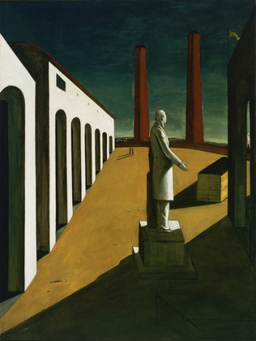

The Enigma of a Day, 1914

Copyright: © 2013 Artists Rights Society (ARS), New York / SIAE, Rome

The modern Italian painter Giorgio de Chirico was born in the port city of Volos in the Grecian province of Thessaly. After training in Athens and Munich, he lived briefly in Milan and Florence before moving to Paris in 1911. There, between 1911-1915, he developed the highly original, ‘metaphysical’ style of painting on which his reputation is chiefly founded. With this singular idiom –– epitomised in his 1914 painting *The* *Enigma of a Day* –– and the critical support of GUILLAUME APOLLINAIRE, he established himself as one of the luminaries of the Parisian avant-garde, alongside PABLO PICASSO and ANDRÉ DERAIN.

Upon Italy’s entry into WWI in 1915, de Chirico was conscripted into the military and stationed in Ferrara, where he remained until the end of the war. There he continued to paint and, in 1917, he established the short-lived *Scuola Metafisica* [Metaphysical School]with the former FUTURIST artist CARLO CARRÀ. Though, by the end of the decade, he had renounced his avant-garde aesthetic for a bygone classicism, his early oeuvre proved hugely influential to future generations of artists, particularly the FRENCH SURREALISTS and the German NEW OBJECTIVITY painters.

De Chirico’s chief contribution to modernism is his *pittura metafisica* [metaphysical painting], invented in Florence in 1910 and developed successively in Paris, Ferrara, and Rome between 1911-1919. Born of the artist’s reading of FRIEDRICH NIETZSCHE and subsequently of ARTHUR SCHOPENHAUER, this *sui generis* and highly conceptual oeuvre was predicated upon de Chirico’s belief that underlying the world of appearances was an imminent, irrational, and invisible metaphysical essence akin to a ‘grand madness’ and perceptible only to rare individuals in moments of quasi-mystical revelation. The peculiar task of the metaphysical painter was to embody the world as it appeared in these sibylline moments of revelation ––that is, as an irreducible ‘enigma’.

In translating his visions into pictorial form, de Chirico subverted the conventions of traditional representational painting, estranging the world of everyday perception by deploying multiple and contradictory perspectives, vertiginously tilted ground planes, austere and fragmentary architecture, multiple and contradictory light sources, dramatic contrasts of light and shadow, uncanny juxtapositions of objects, and dehumanised figures. Through these various and sundry devices, de Chirico conjured an array of mysterious, oneiric, and scenographic urban landscapes that invited the viewer to contemplate the eerie reality he thought to lie hidden beneath the world of appearances. Though for the most part, de Chirico’s painting seems to have been relatively unaffected by contemporary developments in French art, his spatial constructions bear an evident debt to CUBISM.

**List of Works**

1910 *The Enigma of an Autumn Afternoon*

1912 *The Nostalgia of the Infinite*

1913 *The Soothsayer’s Recompense*

1914 *The Song of Love*

1914 *The Enigma of a Day*

1918 *The Disquieting Muses*

**References and Further Reading**

Soby, J.T. (1966) *Giorgio de Chirico*. New York: Museum of Modern Art.

Rubin, W. (1982) *De Chirico.* New York: Museum of Modern Art.

de Chirico, G. (1992) *Hebdomeros with Monsieur Dudron’s Adventure and Other Metaphysical Writings,* ed. Ashbery, J. Cambridge: Exact Change.

de Chirico, G. (1994) *The Memoirs of Giorgio de Chirico*, trans. Crosland, M. New York: Da Capo Press.

Baldacci, P. (1997) *De Chirico: The Metaphysical Period 1888-1919.* Boston: Little, Brown, & Company.